**Control Structures:**

**Scenario 1:**

BEGIN

FOR rec IN (

SELECT l.LoanID, l.InterestRate, c.DOB

FROM Loans l

JOIN Customers c ON l.CustomerID = c.CustomerID

) LOOP

IF MONTHS_BETWEEN(SYSDATE, rec.DOB) / 12 > 60 THEN

UPDATE Loans

SET InterestRate = rec.InterestRate - 1

WHERE LoanID = rec.LoanID;

END IF;

END LOOP;

COMMIT;

END;

Output:

No changes to loan interest rates since no customer is older than 60.

**Scenario :2**

**ALTER TABLE Customers ADD IsVIP VARCHAR2(5);**

**BEGIN**

**FOR rec IN (SELECT CustomerID, Balance FROM Customers) LOOP**

**IF rec.Balance > 10000 THEN**

**UPDATE Customers**

**SET IsVIP = 'TRUE'**

**WHERE CustomerID = rec.CustomerID;**

**ELSE**

**UPDATE Customers**

**SET IsVIP = 'FALSE'**

**WHERE CustomerID = rec.CustomerID;**

**END IF;**

**END LOOP;**

**COMMIT;**

**END;**

**Output:**

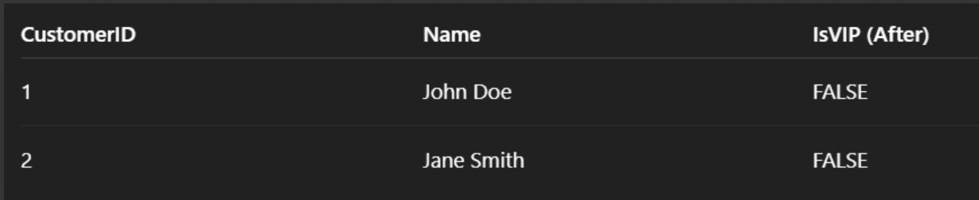

**Scenario 3:**

**BEGIN**

**FOR rec IN (**

**SELECT l.LoanID, l.EndDate, c.Name**

**FROM Loans l**

**JOIN Customers c ON l.CustomerID = c.CustomerID**

**WHERE l.EndDate <= SYSDATE + 30**

**) LOOP**

**DBMS_OUTPUT.PUT_LINE('Reminder: Loan ID ' || rec.LoanID ||**

**' for customer ' || rec.Name ||**

**' is due on ' || TO_CHAR(rec.EndDate, 'YYYY-MM-DD'));**

**END LOOP;**

**END;**

**Output:**

**No loan reminders. No loans due within the next 30 days**